﻿
Meet Mark and Cheryl, the hot new story-telling duo!

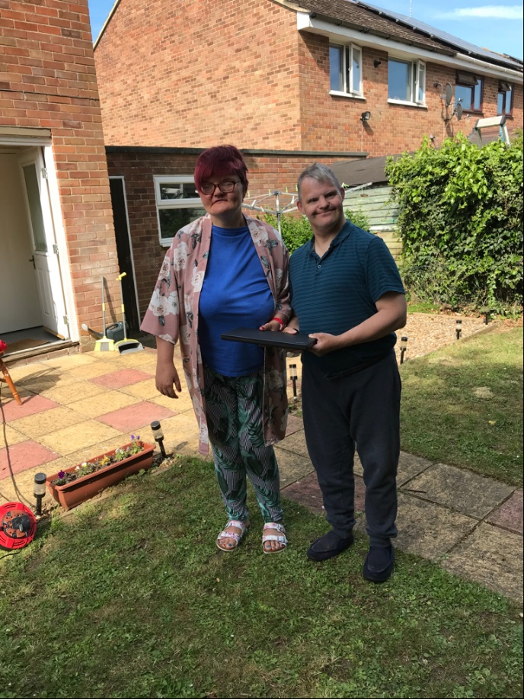

The Story of Mark and Cheryl
For the last 8 years, friends Mark (56) and Cheryl (43) have lived together in a supported living unit in the village of Leiston in Suffolk. In normal times, they each keep a weekly schedule packed with day centre visits, coordinated activities, and catch-ups with friends. Both being home all the time now (and spending more time together than they were used to!) they needed a new structure. So, Gill, one of their carers from Ambient (the care provider that have supported Mark and Cheryl in their home from the start) asked what they would like to do. The pair agreed it would be nice to write a story together. Monday afternoons became the dedicated time to do this. Gill sourced them a laptop and this week, the story telling began!

Story number one – Mark and Cheryl’s Adventure – a Picnic in the Jungle
Mark and Cheryl picked a theme for their first story, a picnic. Imagination took flight, and in under an hour it was finished with Gill- who was capturing their words on the laptop- struggling to keep up. Gill said, “I had no idea they had such imagination! It was wonderful to see them uniting to create a marvelous and mischievous story!” The pair then worked with Gill, choosing pictures online to illustrate the story. Once complete, they insisted Gill call Care Manager, Sue Brown, as they were so pleased with what they had done.

Sue, who together with her team of 18 provide supported living services for over 100 adults with learning disabilities and mental ill health along the Suffolk coast says: “In this very strange and stressful time it’s wonderful to see how Mark and Cheryl are thriving. Like many others with learning disabilities, they find it hard to fully grasp what’s going, and the changes to their lives due to lockdown, but activities like this lets them get fully absorbed in something nice and forget what’s going on.”

Mark and Cheryl are now planning a series and would love people to read them, says Mark, “Inviting a Sealion to a picnic is not a good idea. You’ll have to read our story to find out why!”
.
Can you help? Mark and Cheryl would love to their stories to be brought to life. If you are an illustrator or animator, please get in touch with Davina.sellick@ambient.org.uk

Read their story and find out more www.ambient.org.uk @ambientsupport #markandcheryl #animatecherylandmark

~ Ends~

For more information or please contact Christina Wright chrissie@pr4.com +44 7957 383070

About Ambient Support: www.ambient.org.uk
- One of the Top 20 generic Not-For-Profit Health & Social Care Providers in the UK Ambient Support (formerly known as Heritage Care and Community Options) is a registered UK charity with over 25 years’ experience
- They deliver services that meet the needs of some of the most vulnerable adults in our society. Operating in over 130 locations, they provide over 30 thousand hours of care to people on a weekly basis to support a range of needs due to the ageing process, learning disability or mental illness
- Their wide range of quality specialist services are delivered by dedicated, professional, and passionate staff and their success is built on supporting people to live a full and meaningful life.
- Ambient currently employs around 1,400 people across the UK in a number of settings
- Ambient can also help young adults who are transitioning from Children’s to Adult Learning Disability Services
- The Charity has an above industry average with 88% Registered Services rated as GOOD by CQC.

