**A pioneer for change and transformation, John Goree retires after 4 outstanding decades of service in social care**

(4th May 2021) Local Lincs man, John Goree, celebrated his incredible 39-year career in social care at a retirement event where he was presented with special gifts, vouchers and a memory book. Work colleagues at UK charity care provider, [Ambient Support](https://www.ambient.org.uk/), were delighted to honour John and recognise his dedication and outstanding achievements.

John Goree’s career in social care began in 1982 and from the very beginning he has been a trail blazer for change, introducing new ways of thinking and devising schemes and projects that deliver ‘person-centered’ care.

Resolute that service users should always be heard and at the very heart of decisions, John introduced and ran ‘Get Connected’ meetings giving people using services the chance to be involved and directly influence the care and support being provided. He also developed a team of ‘Quality Checkers’ who are experts by experience, that visit Ambient services to assess quality of care and give feedback from their perspective.

John has also been at the centre of pioneering the ‘Positive Behaviour Support’ (PBS) approach to care and support at Ambient where there are now more than 30 PBS trained coaches across the charity and training available for all staff to incorporate this approach into working practices.

In 2018 John took on the Regional Management of Lincolnshire to add to his existing portfolio of services across The Midlands.

His innovations have seen him modernise the management structure improving efficiency and quality of support given to service users. John’s team now look after over 269 service users in the region, with every registered service in his area rated by CQC as GOOD. It is no surprise that staff satisfaction in his localities rose from 82% to 94% in the most recent staff survey and his team have become some of the most sought-after care teams in the region.

**When asked what makes someone right for a role on his team, he answered:**

*“Courage- morals that revolve around the people we support and conviction in those morals”.*

***And on his lifetime career in social care, John says:***

*“The reason I come to work every day with a smile, even when it’s difficult, is knowing that we can make a positive impact to individual lives.”*

**Mark Milton, CEO, commended John for his dedication. He says:**

*“John has continued to be a true pioneer for positive change throughout his career at Ambient and for that, we will always be grateful. Transforming the lives of service users with his person-centered approach by giving them opportunity and a platform to be heard. John has made an exceptional contribution to our national charity and the people within it, his work and tireless dedication is truly commendable.”*

**Find out about Ambient’s Services across The Midlands and Lincolnshire here:** [**www.ambient.org.uk**](http://www.ambient.org.uk)

***IMAGE CAPTION:* John Goree celebrated his incredible 39-year career in social care at his retirement event at Ambient Support**

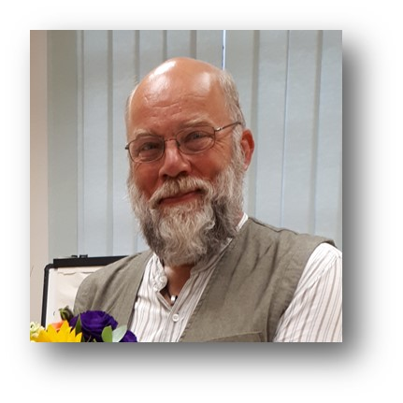

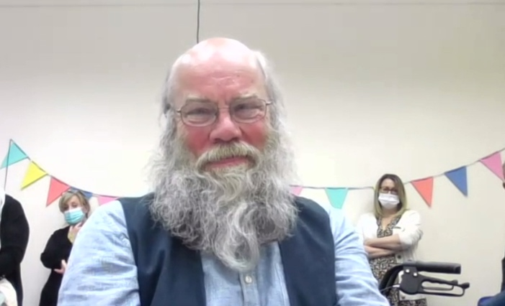

**~~ENDS~~**

**For images or additional comment please contact** [**Chrissie@pr4.com**](mailto:Chrissie@pr4.com) **+44 7957 383070 AND** [**Kathy@pr4.com**](mailto:Kathy@pr4.com) **+44 7788 272009**

**About Ambient Support:** [www.ambient.org.uk](http://www.ambient.org.uk) @ambientsupport

* One of the Top 20 generic Not-For-Profit Health & Social Care Providers in the UK Ambient Support (formerly known as Heritage Care and Community Options) is a registered UK charity with over 25 years’ experience
* They deliver services that meet the needs of some of the most vulnerable adults in our society. Operating in over 130 locations, they provide over 30 thousand hours of care to people on a weekly basis to support a range of needs due to the ageing process, learning disability or mental illness
* Their wide range of quality specialist services are delivered by dedicated, professional, and passionate staff and their success is built on supporting people to live a full and meaningful life.
* Ambient currently employs around 1,325 people across the UK in a number of settings
* Ambient can also help young adults who are transitioning from Children’s to Adult Learning Disability Services
* The Charity has an above industry average with 85% Registered Services rated as Outstanding and GOOD by CQC.