**Ambient Support Appoints New Operations Manager**

**(*6th September 2021)* Ambient Support, one of the top 20 generic Not-For-Profit Health & Social Care Providers in the UK, appoints Will Thornton as their new Regional Manager for Lincolnshire & The Midlands.**

With extensive experience in analysis and development strategies, and a rich background in organisations and disability, Will’s appointment promises to expertly drive the Charity forward to further develop its services across the region.

Dedicated to a career in care and support for disabled people since leaving University, Will has held a number of senior roles within across East and North London, including as a Commissioner plus he has worked for several Midlands based Charities including residential care, community services and more recently for Blind Veterans UK.

Will joins Ambient at a pivotal moment in their new 5-year strategy, he says:

***“It feels great to be part of the change- to help navigate and refocus operationally. I very much connected with the values of Ambient Support, which puts people at the heart of decision-making.”***

Will is overseeing over 100 staff and 40 different services which include older people settings and supported living schemes for adults with a learning disability.

Mark Milton CEO of Ambient is delighted to welcome Will to the Charity, he says:

***“Attracting top talent like Will is critical as we deliver our strategy and accelerate our position as provider of choice. He brings a wealth of experience and his passion and devotion to care over the years speaks volumes.”***

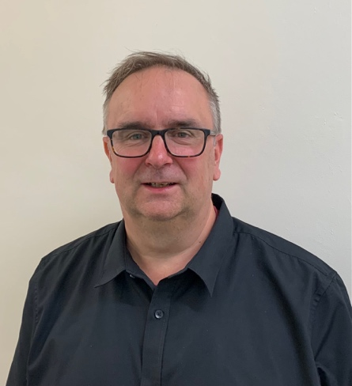

***Will Thornton, newly appointed Operations Manager at Ambient Support***

For more information, hi res images or comment please contact Christina Wright [chrissie@pr4.com](mailto:chrissie@pr4.com) +44 7957 383 070 & Kathryn Rivans [kathy@pr4.com](mailto:kathy@pr4.com)

**About Ambient Support:** [www.ambient.org.uk](http://www.ambient.org.uk) @ambientsupport

* One of the Top 20 generic Not-For-Profit Health & Social Care Providers in the UK, Ambient Support (formerly known as Heritage Care and Community Options) is a registered UK charity with over 25 years’ experience
* They deliver services that meet the needs of some of the most vulnerable adults in society. Operating in over 130 locations, they provide over 30 thousand hours of care to people on a weekly basis to support a range of needs due to the ageing process, learning disability or mental illness
* Their wide range of quality specialist services are delivered by dedicated, professional, and passionate staff and their success is built on supporting people to live a full and meaningful life
* **Latest results from Ambient Support’s 2021- Satisfaction Survey show:** 97% of people supported in **Learning Disability** services said Ambient have helped to make their life better, 95% are happy with the support Ambient give them and 94% of relatives and friends said their loved one is safely supported by Ambient.  
  In **Mental Health Services** 93% said that staff believe in their wellbeing and recovery, 91% of people said they knew how to provide feedback or make a complaint and 89% report being given information and support to make choices  
  In services for **Older People,** 98% report being treated with kindness, dignity and respect and 97% of relatives agree, 91% of friends and relatives report that their loved one’s life has got better since Ambient started supporting them and 97% said that they are happy with the care and support they receive
* Ambient currently employs around 1,325 people across the UK in a number of settings
* Ambient can also help young adults who are transitioning from Children’s to Adult Learning Disability Services
* The Charity has an above industry average with 88% Registered Services rated as Outstanding and GOOD by CQC.