

**Peppercorn House in Ipswich Wins Heroic ‘End of Life Care’ Category in Suffolk Care Awards 2021**

***(16th November 2021)*** *Peppercorn House, an Extra Care service in Ipswich, has won the* ***End of Life Care*** *category in the* ***Suffolk Care Awards 2021*** *which recognises and celebrates individuals and teams who have demonstrated outstanding excellence within their field of work.*

Run by national Charity, Ambient Support, the Peppercorn House team were announced as winners at a virtual awards ceremony on the 11th November. Due to the rise in COVID cases locally, the usual black-tie awards ceremony was moved online so the team at Peppercorn improvised and decorated the communal lounge where staff and tenants gathered to watch the awards streamed onto the large TV.

A delicious food hamper was provided by the Suffolk Care Awards from the Suffolk Food Hall so a special buffet was organised and all staff dressed up for the occasion.

***Ambient Manager, Amanda Retter, wanted to give the team a boost after 18 difficult months due to COVID, so nominated her staff team saying:***

*“The team at Peppercorn House provide excellent end-of-life care and I felt that everyone deserved recognition for their hard work. There are 26 people in our team and each and every person goes above and beyond on a daily basis.*

*“The noise was incredible when we were announced as the winners. There were whoops, shouts and some tears of joy. It was a huge lift to be acknowledged for our dedication and commitment to the people we care for.”*

***Amanda continues:***

*“We provide an Extra Care Service but with the support from the District Nurses we are sometimes able to offer end-of-life care which means so much to the people we support and their families. Some of the people we care for have been with us for 20 years so to them, this is their home and a place where they feel most comfortable.”*

***Bob Pritchard, Ambient’s Regional Manager for East Anglia, says:***

*“This award is a fantastic tribute to the continuous efforts made by the entire team at Peppercorn House and I am incredibly proud of each and every one of the staff. The recognition is so richly deserved, well done!”*

***Christian Bone, Chief Executive of Care Development East who runs the awards, says:***

*“The standard of entries this year was extremely high particularly given the challenges of the last 12 months. Peppercorn House Extra Care Service is quite unique in winning this End of Life Care award, making it even more prestigious. The judges were highly impressed and the services provided really sum up what the best end of life care is all about.”*

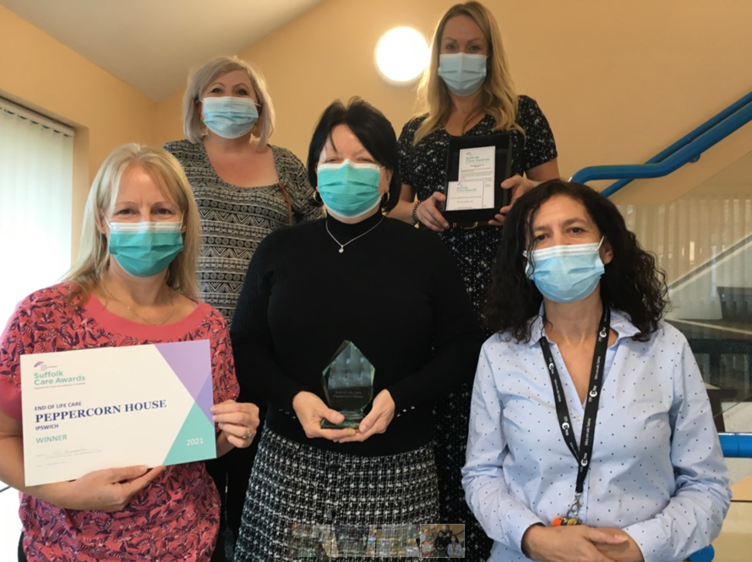

IMAGE CREDIT: Some of the Peppercorn Team - Michale Evans, Deputy Manager, Lisa Boom Care Team Leader, Julie Bigbie Care Team Leader, Kelly Lloyd-Smith Care Team Leader, Kim Hurd Care Support Worker

Peppercorn House, [Extra Care](https://www.ambient.org.uk/older-people-services/extra-care-services/) offers purpose built one bedroomed apartments to the over 60s who wish to live an independent life but may need some extra care and support at times. [www.ambient.org.uk](http://www.ambient.org.uk)

***~ENDS~***

*For more information, images or comment please contact: Christina Wright* [*chrissie@pr4.com*](mailto:chrissie@pr4.com) *+44 7957 383 070 & Kathryn Rivans* [*kathy@pr4.com*](mailto:kathy@pr4.com)

**Notes to Editors:**

**About Ambient Support:** [www.ambient.org.uk](http://www.ambient.org.uk) @ambientsupport

* One of the Top 20 generic Not-For-Profit Health & Social Care Providers in the UK, Ambient Support (formerly known as Heritage Care and Community Options) is a registered UK charity with over 25 years’ experience
* They deliver services that meet the needs of some of the most vulnerable adults in society. Operating in over 130 locations, they provide over 30 thousand hours of care to people on a weekly basis to support a range of needs due to the ageing process, learning disability or mental illness
* Their wide range of quality specialist services are delivered by dedicated, professional, and passionate staff and their success is built on supporting people to live a full and meaningful life
* Latest results from Ambient Support’s 2021- Satisfaction Survey show: 97% of people supported in Learning Disability services said Ambient have helped to make their life better, 95% are happy with the support Ambient give them and 94% of relatives and friends said their loved one is safely supported by Ambient.  
  In Mental Health Services 93% said that staff believe in their wellbeing and recovery, 91% of people said they knew how to provide feedback or make a complaint and 89% report being given information and support to make choices  
  In services for Older People, 98% report being treated with kindness, dignity and respect and 97% of relatives agree, 91% of friends and relatives report that their loved one’s life has got better since Ambient started supporting them and 97% said that they are happy with the care and support they receive
* Ambient currently employs around 1,325 people across the UK in a number of settings
* Ambient can also help young adults who are transitioning from Children’s to Adult Learning Disability Services
* The Charity has an above industry average with 88% Registered Services rated as Outstanding and GOOD by CQC.