**‘Inspirational’ Lincs care worker wins inaugural John Gorée Award**

***(8th December 2021)*** Support Worker, Gillian Cooper, has won the very first John Gorée Award which celebrates exceptional care and support delivered by an Ambient Support team member. Gillian was presented with a certificate by Tom Harrison, Director of Operations and Business Development and a gift of £500 at a surprise celebration today.

National UK charity, [Ambient Support](https://www.ambient.org.uk/), launched the John Gorée Awards in November 2021 as a way of honouring recently retired Regional Manager John following his 40-year career in social care. John has generously donated £5,000 to Ambient to run the award scheme in his name over the next 10 years.

Staff and families were asked to nominate people working in direct care and support roles who exemplify the ‘Ambient Way’ and who truly live by the values of Ambient delivering personal care that allows the people that use their services to reach their full potential and lead their best lives.

John and Tom chose the winner from over 50 nominations received from across all of Ambient’s services.

**John says:**

*“The level of entries was outstanding and it was incredibly inspiring to read so many wonderful nominations, especially given that it’s a new initiative.*

*“We chose Gillian because she clearly demonstrated Ambient’s person-centred approach to care, specifically when she supported an individual to move from a service in London, where she had been for several decades, to her new home in Lincolnshire. Having spoken extensively with the persons’ family, Gillian realised that music was especially significant and by utilising it she not only empowered the person to start making choices in her life, but she also managed to help her overcome a long-standing refusal to vaccinate- and willingly have her Covid vaccinations.*

*“All through the move and settling in period, during the height of the pandemic, Gillian went above and beyond to keep in touch with the family to reassure them, and also showed incredible kindness, patience and encouragement.*

*“I would like to congratulate Gillian on winning the inaugural John Gorée Award.”*

**Tom Harrison delivered the award, £500 and the good news in a surprise visit, he says:**

*“It was an absolute pleasure to present Gillian with the inaugural John Gorée Award and to recognise Gill’s unwavering passion and care for the people she supports.*

*“John has himself been a pioneer for change and transformation in social care and we are delighted to honour his dedication and outstanding achievements by way of creating this special and prestigious John Gorée Award.*

*“A trail blazer for change, John introduced new ways of thinking and devised schemes and projects that deliver ‘person-centered care. This award, celebrates the people within Ambient who deliver care in the way that John championed for all those many years.”*

John Gorée’s career in social care began in 1982. In 2018 John took on Ambient’s Regional Management of Lincolnshire to add to his existing portfolio of services across the Midlands. John retired in April 2021.

**Find out about Ambient’s Services across The Midlands and Lincolnshire here:** [**www.ambient.org.uk**](http://www.ambient.org.uk)

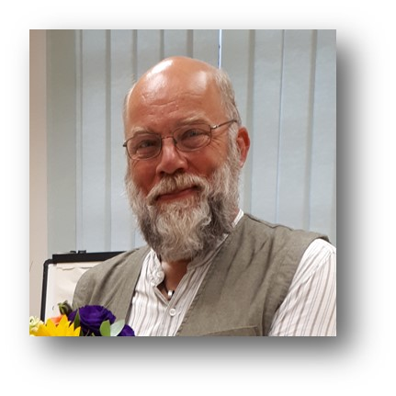

***Image: The John Gorée Award celebrates staff who deliver exceptional care and support to the people they look after***

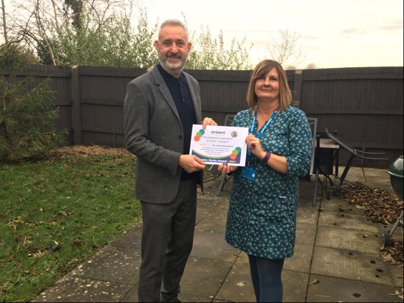

***Image: Ambient Support’s Tom Harrison surprises support worker, Gillian Cooper, with the John Gorée Award***

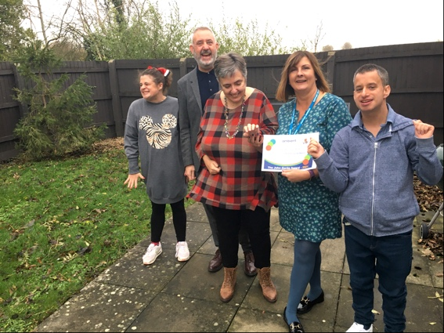

***Image: Ambient Support’s Tom Harrison & residents celebrate Gillian Cooper winning the John Gorée Award***

**~~ENDS~~**

**For images or additional comment please contact** [**Chrissie@pr4.com**](mailto:Chrissie@pr4.com) **+44 7957 383070 AND** [**Kathy@pr4.com**](mailto:Kathy@pr4.com) **+44 7788 272009**

**About Ambient Support:** [www.ambient.org.uk](http://www.ambient.org.uk) @ambientsupport

* One of the Top 20 generic Not-For-Profit Health & Social Care Providers in the UK, Ambient Support (formerly known as Heritage Care and Community Options) is a registered UK charity with over 25 years’ experience
* They deliver services that meet the needs of some of the most vulnerable adults in society. Operating in over 130 locations, they provide over 30 thousand hours of care to people on a weekly basis to support a range of needs due to the ageing process, learning disability or mental illness
* Their wide range of quality specialist services are delivered by dedicated, professional, and passionate staff and their success is built on supporting people to live a full and meaningful life
* Latest results from Ambient Support’s 2021- Satisfaction Survey show: 97% of people supported in Learning Disability services said Ambient have helped to make their life better, 95% are happy with the support Ambient give them and 94% of relatives and friends said their loved one is safely supported by Ambient.  
  In Mental Health Services 93% said that staff believe in their wellbeing and recovery, 91% of people said they knew how to provide feedback or make a complaint and 89% report being given information and support to make choices  
  In services for Older People, 98% report being treated with kindness, dignity and respect and 97% of relatives agree, 91% of friends and relatives report that their loved one’s life has got better since Ambient started supporting them and 97% said that they are happy with the care and support they receive
* Ambient currently employs around 1,325 people across the UK in a number of settings
* Ambient can also help young adults who are transitioning from Children’s to Adult Learning Disability Services
* The Charity has an above industry average with 88% Registered Services rated as Outstanding and GOOD by CQC.