**Peppercorn House awarded a High Commendation in national Third Sector Awards**

***(4 October 2022) Peppercorn House, an Extra Care service in Ipswich, received a High Commendation in the Frontline Team of the Year category at the prestigious Third Sector Awards this week.***

These national awards celebrate the outstanding achievements and contribution made by individuals, teams in not for profit and charitable organisations across the year. Winners were announced at an esteemed lunchtime reception in central London, hosted by the writer and performer Ben Bailey Smith.

Run by national charity, [Ambient Support](https://www.ambient.org.uk/), the Peppercorn House frontline team were awarded for their delivery of exceptional service and for going the extra mile to support beneficiaries through the Covid-19 pandemic.

***Ambient Manager, Amanda Retter, says the commendation was a boost for the team after a difficult two years:***

“The pandemic was a very difficult time for everyone in care, but we knew we had to pull together and be strong for the people we support- and for each other.

“The team showed huge passion, resilience and creativity and we continued to provide excellent care and to put the people we support at the heart of our work to ensure they had the highest quality of life possible.

“I am incredibly proud of my team and to be awarded with a High Commendation gives us a fantastic moral boost, it will take pride of place in our communal area.”

Pulling together like never-before, the team worked creatively to ensure that tenants were safe, secure, stimulated, supported, engaged and informed during the crisis. Going above and beyond their normal duties many staff worked additional hours and took on new roles- one staff member became the in-house hairdresser to keep spirits and appearances up whilst another became a personal shopper- which all helped to combat feelings of social isolation, anxiety, and depression.

***Bob Pritchard, Ambient’s Regional Manager for East Anglia, says:***

“The Peppercorn House team clearly live Ambient’s values of delivering outstanding person-centered support but more than that, they demonstrate the very best of what it is to be social care professionals. Their commitment and unwavering determination to support those that needed it most during incredibly difficult circumstances is truly heart-warming and we are delighted for this recognition which the team so richly deserve. Congratulations!”

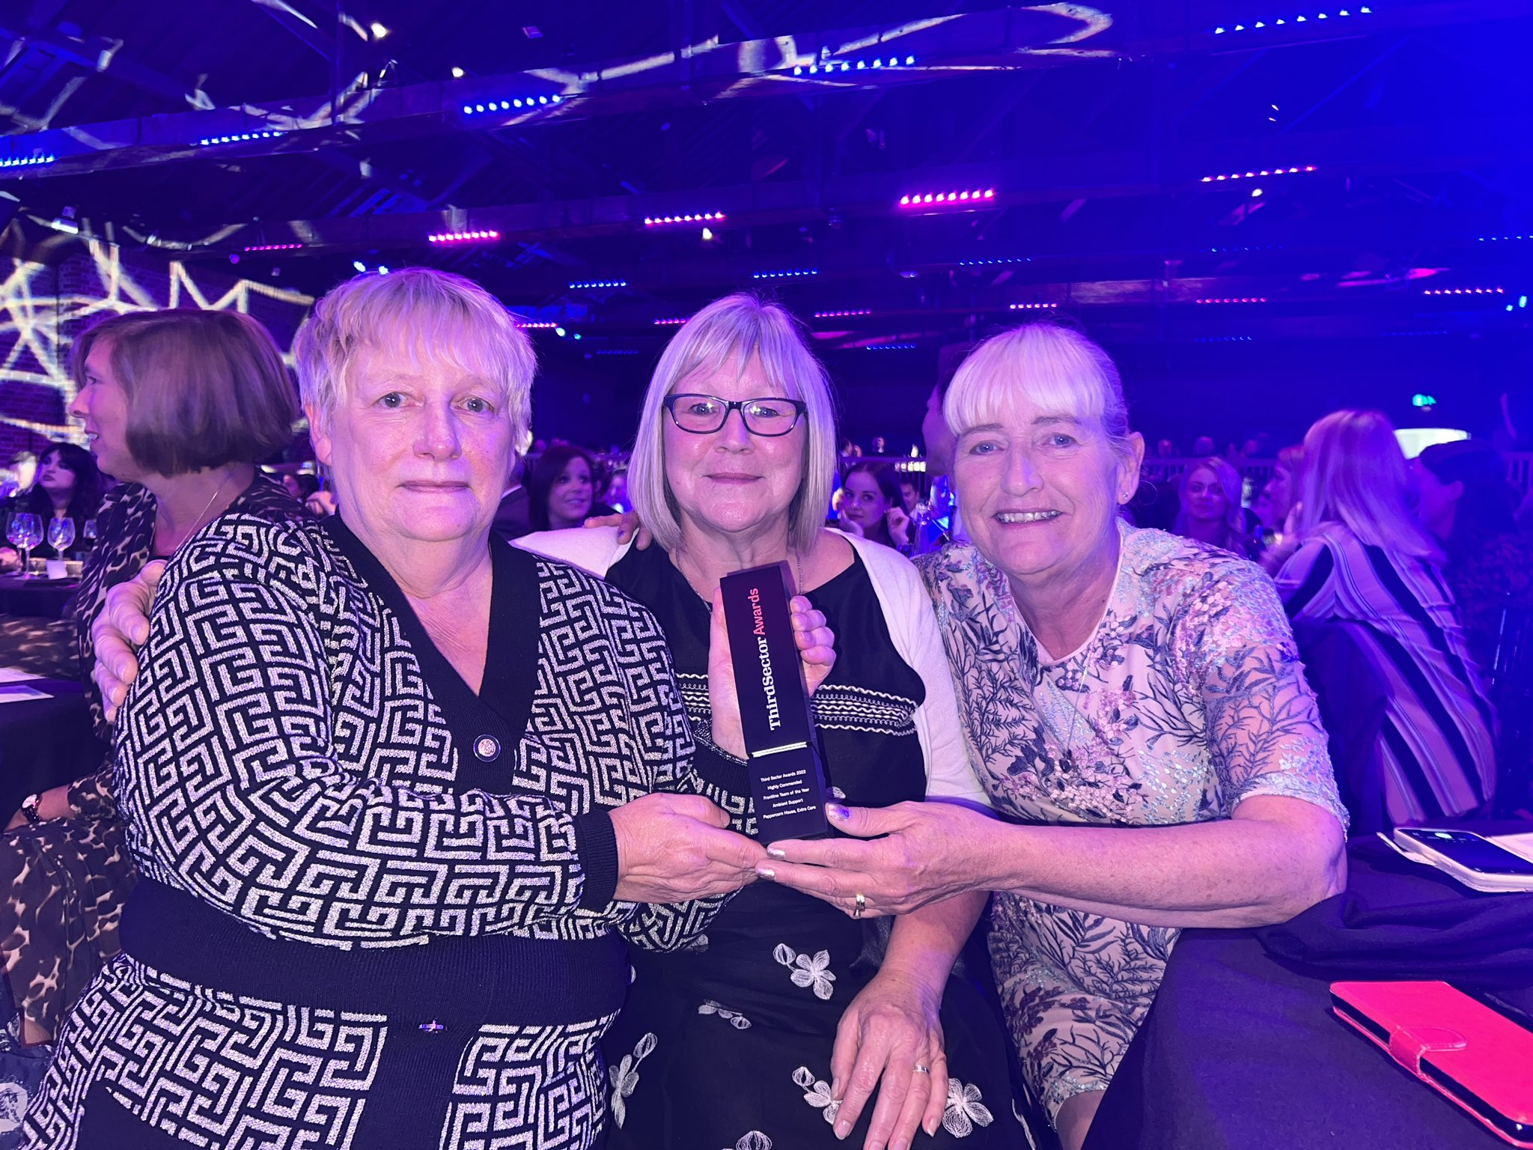

***IMAGE CREDIT:*** Ambient Support’s Amanda Retter, Helen Markwell, Julie Sadler received a High Commendation at Third Sector Awards on behalf of the team at Peppercorn House, Ipswich.

Peppercorn House, [Extra Care](https://www.ambient.org.uk/older-people-services/extra-care-services/) offers purpose built one bedroomed apartments to the over 60s who wish to live an independent life but may need some extra care and support at times. [www.ambient.org.uk](http://www.ambient.org.uk)

***~ENDS~***

*For more information, images or comment please contact* [*kathy@pr4.com*](mailto:kathy@pr4.com) *07788 272 009*

**Notes to Editors:**

**About Ambient Support:**[www.ambient.org.uk](http://www.ambient.org.uk/)  @ambientsupport

* Ambient Support is one of the Top 20 generic Not-For-Profit Health & Social Care Providers in the UK
* They deliver services that meet the needs of some of the most vulnerable adults in society  
  Operating in 110+ locations, they provide over 30 thousand hours of care to people on a weekly basis to support a range of needs due to the ageing process, learning disability or mental illness
* Ambient employs around 1100+ members of staff.  In the 2021 **staff satisfaction survey 98% of people who responded said they like the work that they do**.
* Their wide range of quality specialist services are delivered by dedicated, professional, and passionate staff and their success is built on supporting people to live a full and meaningful life
* Latest results from Ambient Support’s 2022- People We Support Satisfaction Survey show:  
  **82% believe that Ambient supports them to live their life in the way they want to and 85% say we have helped make their lives better since support them.**​ **A total of 82% of people would tell others that they like Ambient.**
* Ambient currently supports around 950+ people across the UK in a number of care settings
* Ambient can also help young adults who are transitioning from Children’s to Adult Learning Disability Services
* 87% of CQC registered locations rated Good or Outstanding