**\*EMBARGOED 01 JUNE 2023\***

**Get your motor runnin’**

***Motorbike enthusiast with a learning disability finds volunteer work at local mechanics***

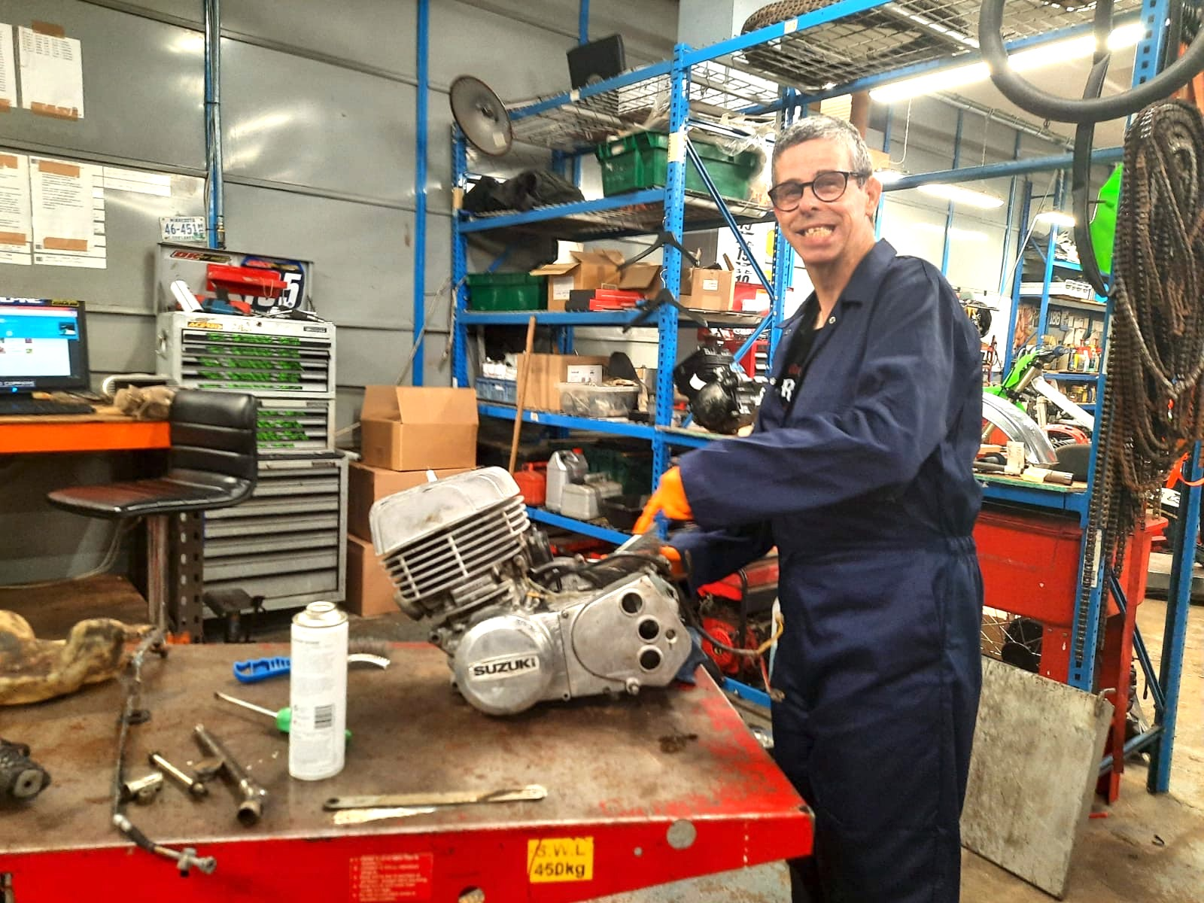

***Image: Darren has a keen interest in motorbikes***

*(June 2023)* **A Team Leader at a Learning Disability Supported Living Service in Staffordshire run by national charity, Ambient Support, went above and beyond to secure volunteer work for Darren, an individual with a learning disability, at local mechanics, DK Motorcycles.**

Darren has always loved motorbikes. His favourite bike is a Kawasaki Ninja and he’s even met his idol, John McGuiness a Tourist Trophy races (TT) rider.

When Darren first moved to the supported living service in Staffordshire, his Team Leader, Melissa Gadd, was keen to understand his likes and interests. **She says:**

“I discovered that Darren has a real passion for motorbikes and mechanics, so I spoke to the local mechanics garage, DK Motorcycles, and asked if it was possible for Darren to trial voluntary work for one day a week. They agreed and Darren has now been volunteering at DK Motorcycles for two and a half years and is absolutely thriving in the workplace environment. Darren is not paid but he is a willing and enthusiastic volunteer which gives him flexibility and suits his personal needs.

“He has built a good working relationship with his manager and helps him to strip bike parts and place them onto the internet to sell. He also enjoys the comradery and sits and has lunch in the canteen. His confidence has grown considerably and he looks visibly happy when he returns at the end of his working day.”

**Darren says:**

“Working at DK Motorcycles is really fun. I enjoy working with Matt and he has become a good friend. He has shown me how to use tools and strip and clean bike parts. When I go to work, I like to look at the race bikes. There are about a thousand bikes in the showroom and it is amazing!”

**Matt Cartlidge, Mechanic at DK Motorcycles, says:**   
"Darren has been working with me for over two and half years now, he helps with a lot of jobs in the workshop, such as cleaning various bike parts ready for reselling. Occasionally, he goes around the main display room and polishes the bikes that are for sale. I enjoy teaching him about what the various parts of engines do.   
  
**When asked what Matt thinks about giving people with learning disabilities equal opportunities in a workplace, he said:**   
"I think it's good for Darren to interact with the other mechanics in the workshop, it’s given him a good sense of routine and independence. I believe it's positive for his mental health and working here has boosted Darren’s confidence. I also think it encourages the wider team to be more understanding and accepting of people with a learning disability and helps to encourage engagement. We really enjoy seeing Darren each week."

**Will Thornton, Regional Manager of Lincolnshire and Midlands at Ambient Support, says:**

“Our LD service in Staffordshire is an excellent example of Ambient Support’s exceptional person-centered care approach. The People We Support (PWS) are involved in all decision-making processes and at their request, given more responsibility to help manage their home- from looking after pets to growing vegetables in the garden- which encourages independence and boosts confidence.

“Darren’s volunteering work shows the importance of understanding people’s preferences, their life interests and then turning that into a reality to ensure good quality of life. We’re extremely proud of our care teams and their hard work.”

The Learning Disability Supported Living Service in Staffordshire provides 24-hours support for three individuals and is an example of exceptional person-centered care.

Visit [www.ambient.org.uk](http://www.ambient.org.uk/) for more information.

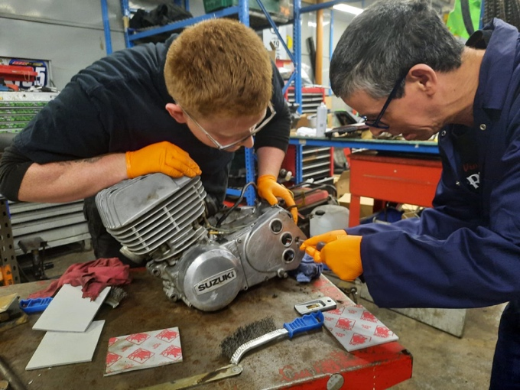

***Image: Darren volunteers one day a week at DK Motorcycles***

**~ENDS~**

For images or additional comment please contact [Kathy@pr4.com](mailto:Kathy@pr4.com) +44 7788 272009

**Notes to Editors:**

**About Learning Disability Week (LDW):**

* LDW 2023 is 19 to 25 June
* It is an annual campaign, run by Mencap, which is all about making sure the world hears what life is like if you have a learning disability
* <https://www.mencap.org.uk/LDWeek> for updates

**About Ambient Support:**[www.ambient.org.uk](http://www.ambient.org.uk/)  @ambientsupport

* Ambient Support is one of the Top 20 generic Not-For-Profit Health & Social Care Providers in the UK
* They deliver services that meet the needs of some of the most vulnerable adults in society
* Operating in 110+ locations, they provide over 30 thousand hours of care to people on a weekly basis to support a range of needs due to the ageing process, learning disability or mental illness
* **Ambient is certified as a Great Place to Work**following an in-depth survey of staff in October 2022. Survey findings showed that**84%** said they felt they made a difference and were proud of what they accomplished. Whilst almost **90%** said they are treated fairly, regardless of age, race, or sexual orientation. Similarly, **83%** of employees said that when they joined Ambient, they were made to feel welcome
* Ambient’s range of quality specialist services are delivered by dedicated, professional, and passionate staff and their success is built on supporting people to live a full and meaningful life
* Latest results from Ambient Support’s 2022- People We Support Satisfaction Survey show:  
  **82% believe that Ambient supports them to live their life in the way they want to and 85% say we have helped make their lives better since support them.**​ **A total of 82% of people would tell others that they like Ambient**
* Ambient currently supports around 950+ people across the UK in a number of care settings
* Ambient can also help young adults who are transitioning from Children’s to Adult Learning Disability Services
* **85.5% of CQC registered locations rated Good or Outstanding**
* Ambient Support partners with EasyFundraising which allows people to turn their everyday online shopping purchases into donation funds for the charity, without costing extra money. Find out more [HERE](https://www.ambient.org.uk/ambient-on-easyfundraising/) and visit Ambient’s EasyFundraising link [HERE](https://www.easyfundraising.org.uk/causes/ambient-support/?utm_campaign=raise-more&utm_medium=clipboard&utm_content=rm-cpl)