

Care homes open their doors to locals across Bucks for coffee & cake

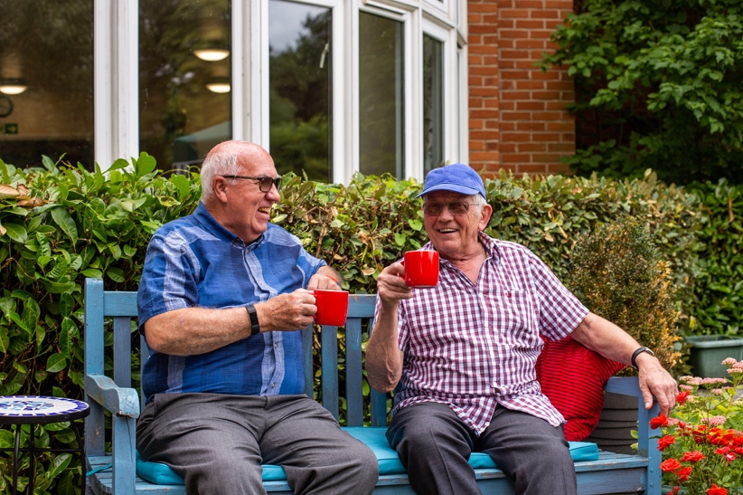
Care homes across Bucks will open their doors to the local community ©Ambient Support

(03 June 2024) Local residents who may be thinking about extra care and support for their loved ones are being encouraged to join a Coffee & Cake Open Morning held in care homes across Bucks on Tuesday 25 June.

The Croft in Amersham, The Chestnuts in Aylesbury and Hazlemere Lodge in High Wycombe, all run by charity Ambient Support, will host the informal coffee morning from 10:30 until 12:00 as part of Care Home Open Week from 24 – 30 June 2024.

Rob Hunt, Head of Older People’s Services at Ambient Support, says:
“Thinking about next steps for older relatives who may need extra care and support can feel quite daunting- so we hope our relaxed coffee morning will minimise some of the apprehension that people may understandably be feeling when making the decision to visit a care home.

“Everyone is welcome, and visitors will be able to experience first-hand the friendly, supportive, home-from-home environments at the care homes and find out about day-to-day life for residents including the varied activities, outings and events organised and enjoy the beautiful gardens which are all fully wheelchair accessible.

“Most importantly, it will give people the chance to chat to our friendly staff and residents and ask lots of questions if they wish to.”

Care Home Open Week is organised by Championing Social Care to connect care homes across the country with their local community.

Rob continues:
“Care Home Open Week is an incredibly important initiative as it opens social care up to the wider community and shines a light on the amazing work staff provide to improve the lives of the people they support. The week also highlights the value of the social care sector to society and allows us to show the local community our facilities, services and remind them we are here if they need support in the future.

“Everyone deserves to live a meaningful and full life regardless of age, health or disability and through this event we hope to provide an enjoyable day and build strong connections between the local community and our service.”

The Bucks care homes all support older people but vary in size and their offering:

The Chestnuts is a community-based residential care home in Aylesbury able to provide a home to 64 people, and can support up to 48 residents with specific dementia care needs. Lavric Road, Aylesbury, Buckinghamshire, HP21 8JN. Contact 01296 414980 or email TheChestnuts@Ambient.org.uk
The Croft is a community-based residential care home in Amersham able to provide care and support for up to 60 residents including 31 residents with a higher level of specific dementia care needs. The Penningtons, Chestnut Lane, Amersham, Buckinghamshire, HP6 6EJ
Contact 01494 732500 or email TheCroft@Ambient.org.uk

Hazelmere Lodge is a residential care home in High Wycombe able to provide a home to 64 people and able to support up to 32 residents with nursing care needs and up to 16 residents living with dementia. Barn Lane, Off Cedar Avenue, Hazlemere, High Wycombe, Buckinghamshire, HP15 7BQ. Contact 01494 767800 or email HazlemereLdg@Ambient.org.uk

Visit www.ambient.org.uk

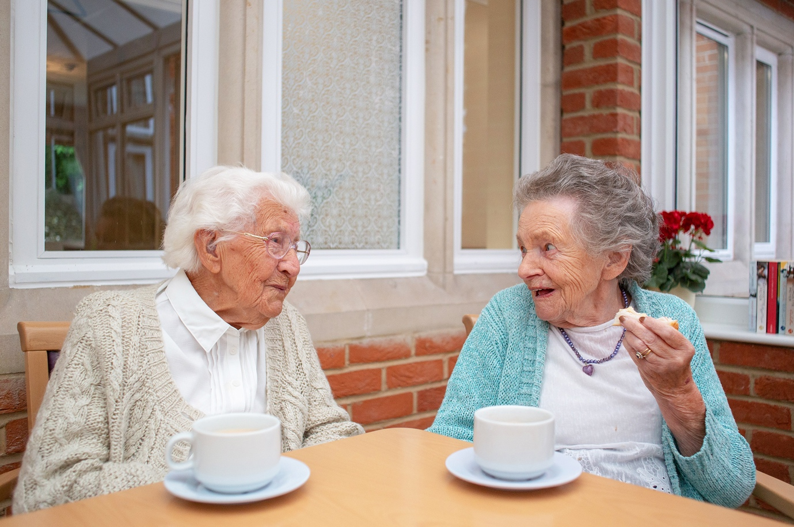Coffee & Cake Morning at Ambient Support’s care homes ©Ambient Support

For more information, images or further commentary please contact kathy@pr4.com / 07788 272 009

Notes to Editors:
About Ambient Support: www.ambient.org.uk @ambientsupport
- Ambient Support is one of the Top 20 generic Not-For-Profit Health & Social Care Providers in the UK
- They deliver services that meet the needs of some of the most vulnerable adults in society
- Operating in 110+ locations, they provide over 30 thousand hours of care to people on a weekly basis to support a range of needs due to the ageing process, learning disability or mental illness
- Ambient is certified as a Great Place to Work following an in-depth survey of staff in October 2022. Survey findings showed that 84% said they felt they made a difference and were proud of what they accomplished. Whilst almost 90% said they are treated fairly, regardless of age, race, or sexual orientation. Similarly, 83% of employees said that when they joined Ambient, they were made to feel welcome
- Ambient’s range of quality specialist services are delivered by dedicated, professional, and passionate staff and their success is built on supporting people to live a full and meaningful life
- Latest results from Ambient Support’s 2023- People We Support Satisfaction Survey show:
84% say they are happy with the care Ambient provide, 82% feel that their lives have improved since Ambient started supporting them and 93% agree that they would recommend Ambient Support
- Ambient currently supports around 900+ people across the UK in a number of care settings
- Ambient Support partners with EasyFundraising which allows people to turn their everyday online shopping purchases into donation funds for the charity, without costing extra money. Find out more HERE and visit Ambient’s EasyFundraising link HERE

