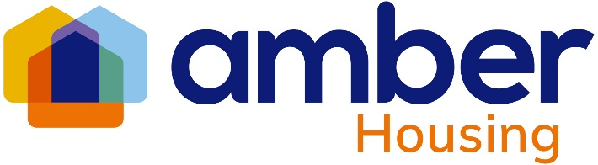

**Amber Housing unveils fresh new brand**

*(14 October 2024)* **Today, Amber Housing, quality provider of supported living accommodation for people with disabilities, announces the launch of its rebrand which represents the organisation’s ambition to ‘lead in the modern era of supported living.’**

### Unveiling a fresh new brand with a vibrant new logo and [a streamlined digital presence](http://www.amberhousing.co.uk/), the rebrand reflects Amber Housing’s commitment to growth and modernisation, positioning it as a partner of choice for developers seeking to provide inclusive and accessible housing provision.

[Amber Housing](http://www.amberhousing.co.uk) operates as a fully owned subsidiary of UK charity care provider [Ambient Support](https://www.ambient.org.uk/about-us/) providing quality housing management, property development and facilities management across the UK.

The new Amber Housing branding visually aligns closely with Ambient Support, representative of the organisations’ aligned mission and values. With a shared focus on providing person-centred support and housing in the community, the synergy between the two organisations further consolidates their collective appeal to new prospective developers and landlords.

**CEO Troy Henshall expressed his excitement for the future saying:**

 “Our new brand reflects our values of inclusion, support, and empowerment. We are proud to be at the forefront of providing high-quality housing for people with disabilities in the community and are excited to strengthen partnerships with developers who share our vision.”

**Mark Milton, CEO of Ambient Support, says:**

"Amber Housing’s rebrand is a fantastic reflection of the shared values and vision that both Amber and Ambient Support hold dear. By aligning our brands, we are reinforcing our commitment to providing high-quality, person-centered services. This fresh new identity positions Amber for continued growth and success as we work together to create even stronger partnerships and deliver vital housing and support to those with a disability across the country."

Amber’s redesigned website offers a user-friendly experience, with easy access to information for those customers seeking information about their tenancies and for professional partners, stakeholders and developers looking to work with the organisation. Visit [www.amberhousing.co.uk](http://www.amberhousing.co.uk) / [LinkedIn](https://uk.linkedin.com/company/amber-housing)

For further information about national charity, Ambient Support, visit [www.ambient.org.uk](http://www.ambient.org.uk) and follow @ambientsupport

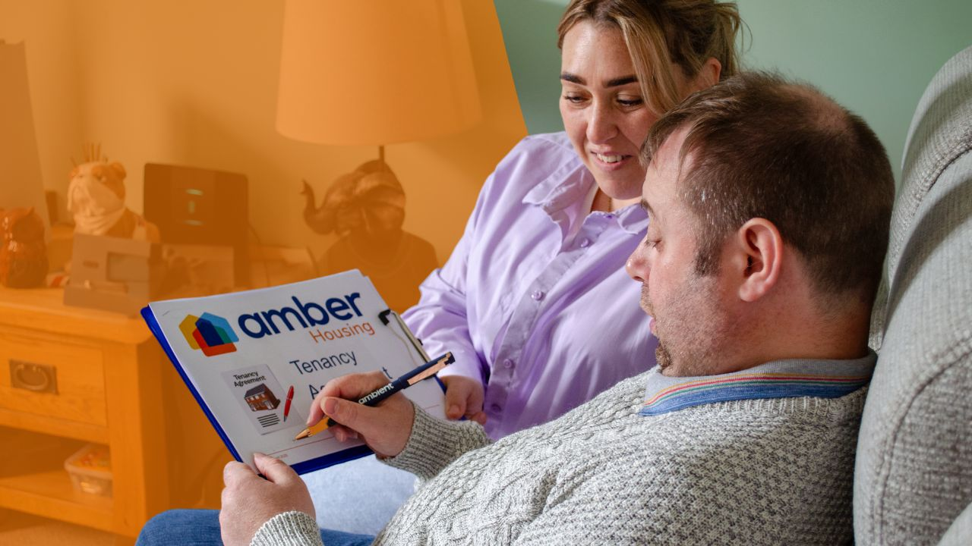

For more information, images or comment please contact [kathy@pr4.com](mailto:kathy@pr4.com) / 07957 383 070

**Notes to Editors:**

**About Amber Housing:** [www.amberhousing.co.uk](http://www.amberhousing.co.uk) / [LinkedIn](https://uk.linkedin.com/company/amber-housing)

* Amber Housing was formed as a subsidiary of Ambient Support Limited in 2006.
* The organisation has charitable objects and is a Registered Society under the Co-operative and Community Benefit Societies Act 2014.
* The organisation comprises of an independent Board of Management together with a highly motivated, diverse, experienced and dedicated staff team.

**About Ambient Support:**[www.ambient.org.uk](http://www.ambient.org.uk/) / @ambientsupport

* Ambient Support delivers services that meet the needs of some of the most vulnerable adults in society
* Operating in over 100 locations, they provide in excess of 30 thousand hours of care to people on a weekly basis to support a range of needs due to the ageing process, learning disability or mental illness
* **Ambient is certified as a Great Place to Work**following an in-depth survey of staff in October 2022. Survey findings showed that**84%** said they felt they made a difference and were proud of what they accomplished. Whilst almost **90%** said they are treated fairly, regardless of age, race, or sexual orientation. Similarly, **83%** of employees said that when they joined Ambient, they were made to feel welcome
* Ambient’s range of quality specialist services are delivered by dedicated, professional, and passionate staff and their success is built on supporting people to live a full and meaningful life
* Latest results from Ambient Support’s 2023- People We Support Satisfaction Survey show:   
  **84% say they are happy with the care Ambient provide, 82% feel that their lives have improved since Ambient started supporting them and 93% agree that they would recommend Ambient Support**
* Ambient currently supports around 900+ people across the UK in a number of care settings
* Ambient Support partners with EasyFundraising which allows people to turn their everyday online shopping purchases into donation funds for the charity, without costing extra money. Find out more [HERE](https://www.ambient.org.uk/ambient-on-easyfundraising/) and visit Ambient’s EasyFundraising link [HERE](https://www.easyfundraising.org.uk/causes/ambient-support/?utm_campaign=raise-more&utm_medium=clipboard&utm_content=rm-cpl)

